Github https://github.com/k256534/PF-labs

Abrar ul hassan
25k 6534 2A

#1
#include <stdio.h>

int main() {
int a[5], i, temp;

printf("Enter 5 numbers:\n");
for(i=0;i<5;i++)
scanf("%d",&a[i]);

temp = a[4];

for(i=4;i>0;i--)
a[i] = a[i-1];

a[0] = temp;

printf("Output:\n");
for(i=0;i<5;i++)
printf("%d ",a[i]);

return 0;
}
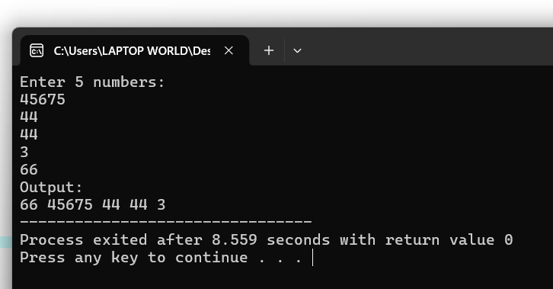

#2

#include <stdio.h>

int main() {
int a[10], i, num, count=0;

printf("Enter 10 numbers:\n");
for(i=0;i<10;i++)
scanf("%d",&a[i]);

printf("Enter number to search: ");
scanf("%d",&num);

for(i=0;i<10;i++)
if(a[i]==num)
count++;

if(count==0)
printf("Number not found");
else
printf("Number occurs %d times",count);

return 0;
}
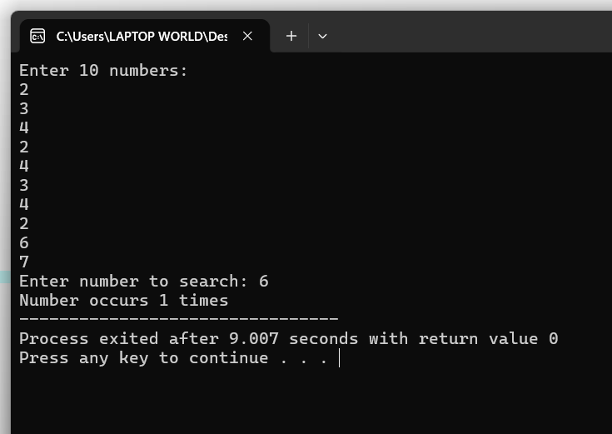

#3
#include <stdio.h>

int main() {
int pass[10], fail[10];
int i=0, p=0, f=0, mark;
float avgp=0, avgf=0;

while(1)
{
printf("Enter mark (-1 to stop): ");
scanf("%d",&mark);

if(mark==-1)
break;

if(mark>=5 && mark<=10)
{
pass[p]=mark;
avgp+=mark;
p++;
}
else if(mark>=0 && mark<=5)
{
fail[f]=mark;
avgf+=mark;
f++;
}
}

printf("\nPass Marks:\n");
for(i=0;i<p;i++)
printf("%d ",pass[i]);

printf("\nAverage Pass = %.2f",avgp/p);

printf("\nFail Marks:\n");
for(i=0;i<f;i++)
printf("%d ",fail[i]);

printf("\nAverage Fail = %.2f",avgf/f);

return 0;
}

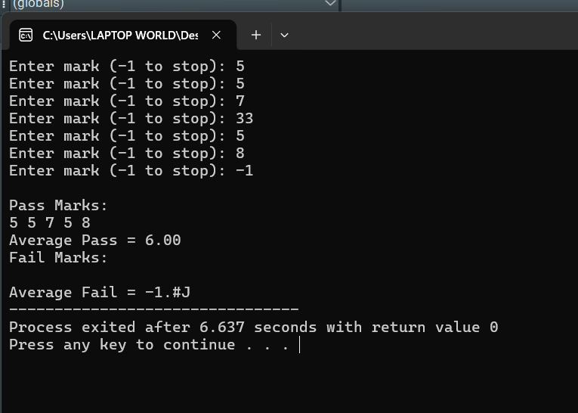

#4
#include <stdio.h>

int main() {
char str[100];
int i=0;

printf("Enter sentence: ");
scanf("%[^\n]",str);

while(str[i]!='\0')
{
if(str[i]>='a' && str[i]<='z')
str[i] = str[i] - 32;
else if(str[i]>='A' && str[i]<='Z')
str[i] = str[i] + 32;

i++;
}

printf("Converted: %s",str);

return 0;
}
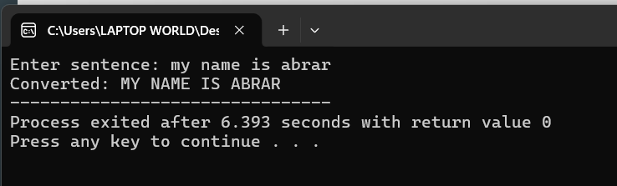

#5
#include <stdio.h>

int main() {
int a[10], i, max, min;

printf("Enter 10 numbers:\n");
for(i=0;i<10;i++)
scanf("%d",&a[i]);

max=min=a[0];

for(i=1;i<10;i++)
{
if(a[i]>max)
max=a[i];

if(a[i]<min)
min=a[i];
}

printf("Difference = %d",max-min);

return 0;
}

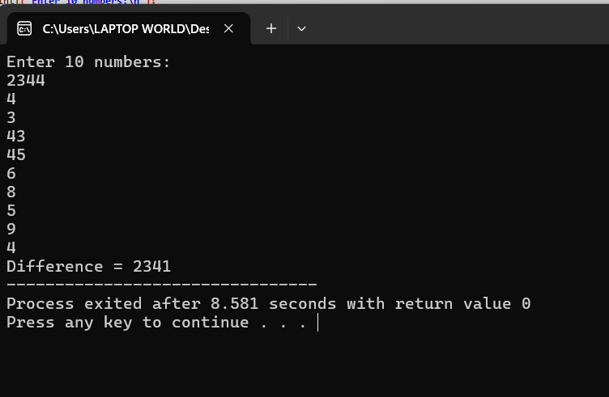

#6
#include <stdio.h>

int main() {
char str[100];
int i=0,v=0,c=0;

printf("Enter word: ");
scanf("%s",str);

while(str[i]!='\0')
{
if(str[i]=='a'||str[i]=='e'||str[i]=='i'||str[i]=='o'||str[i]=='u'||
str[i]=='A'||str[i]=='E'||str[i]=='I'||str[i]=='O'||str[i]=='U')
v++;
else
c++;

i++;
}

printf("Vowels = %d\n",v);
printf("Consonants = %d",c);

return 0;
}
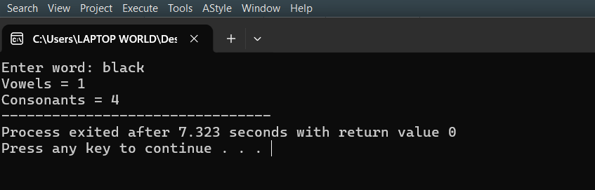

#7
#include <stdio.h>

int main() {
int a[10], i, j;

printf("Enter 10 numbers:\n");
for(i=0;i<10;i++)
scanf("%d",&a[i]);

for(i=0;i<10;i++)
{
for(j=i+1;j<10;j++)
{
if(a[i]==a[j])
a[j] = -1;
}
}

printf("Updated array:\n");
for(i=0;i<10;i++)
printf("%d ",a[i]);

return 0;
}
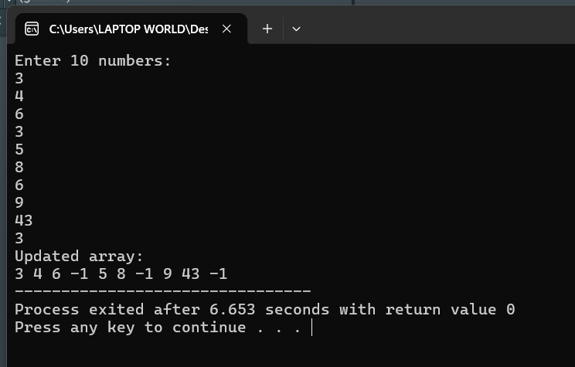

#8
#include <stdio.h>

int main() {
char str[100];
int i=0;

printf("Enter string: ");
scanf("%[^A-Za-z]",str);

printf("Non alphabet characters:\n");

while(str[i]!='\0')
{
printf("%c",str[i]);
i++;
}

return 0;
}
